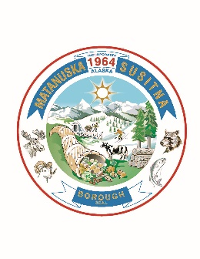
MATANUSKA-SUSITNA BOROUGH
TALKEETNA SEWER & WATER BOARD
for
SERVICE AREA NO. 36

Andrew Haag, Chair Jane Steere, Vice Chair Ryan Sheldon James Kellard Vacant

AGENDA

REGULAR MEETING

Talkeetna Public Library Microsoft Teams
24645 Talkeetna Spur Road Meeting ID: 219 084 064 569
Talkeetna, AK 99676 Passcode: Rwkjk6

February 5, 2025
1:00 pm

- CALL TO ORDER

- ROLL CALL

- APPROVAL OF AGENDA

- APPROVAL OF MINUTES OF PRECEDING MEETINGS

  - Regular Meeting: January 8, 2025

- STAFF REPORT

  - TSW Supervisor (Amanda Fleming)
  - MSB Engineer (Mike Campfield)

- AUDIENCE PARTICIPATION

- UNFINISHED BUSINESS

  - Meeting Procedures
  - Service Area Rule & Rate Changes
  - Public Input Meeting – May 7, 2025

- NEW BUSINESS
  - Budget Preparations for FY26
- COMMENTS FROM THE BOARD

- NEXT MEETING

  - Regular Meeting: March 5, 2025, 1:00 pm, Talkeetna Public Library & Teams

- ADJOURNMENT

