Characteristics of a Leader  The mark of a true leader is not a position or title held, but how many people are willing to follow him or her. Santa Clara University and the Tom Peters group outline the following leadership characteristics:  - Honest  - Competent  - Forward-looking  - Inspiring  - Intelligent  - Fair-minded  - Broad-minded  - Courageous  - Straightforward  - Imaginative | Kouzes and Posner  In their book, The Leadership Challenge, the authors identified five abilities that were crucial to successful leadership:  - Model the Way  You must lead by example. You can’t come into work 10 minutes late every day if you want your employees to arrive on time.  - Inspire a Shared Vision  If you capture the imagination, you will inspire creative thought and increase loyalty.  - Challenge the Process  Don’t continue doing something just because “We’ve always done it that way.” Situations change, and sometimes a policy or procedure never worked well in the first place. Think outside the box.  - Enable Others to Act  Truly empower people to act on their own within their level of authority.  - Encourage the Heart  A positive attitude is infectious.
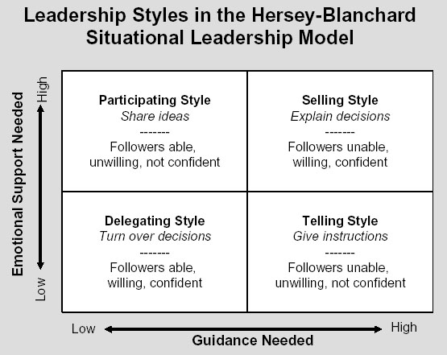
Situational Leadership
The Situational Leadership model addresses four types of leadership styles:
- Telling
- Selling
- Participating
- Delegating

Creating an Action Plan
- Set Leadership Goals
In leadership, as in life, you will never come to the end of your learning, but you want to rank in priority order those qualities you want to develop.
- Address the Goals
Determine how you will accomplish your goals. Do you feel you need to learn more about teamwork so you can better lead a team? Join a team sport. Do you want to communicate better? Take a creative writing class or join Toastmasters and get some public speaking experience.
- Seek Inspiration
Learn about a variety of leaders, their styles and how they dealt with challenges. Read books and conduct research on the internet or at libraries.
- Choose a Role Model
Based on your research; choose a role model that fits your personality. Read several biographies and find videos on his or her life.
- Seek Experience
Take a leadership role on a social group or club. Gain experience working with people on many levels.
- Create a Personal Mission Statement
Imagine your legacy. What do you want to be remembered for? What do you want people to think of you? What kind of leader are you determined to be? Write a statement that defines who you will become.
The Art of Persuasion  Aristotle identifies three important factors: ethos, pathos, and logos.  - Ethos (credibility) persuades people using character.  - Pathos (emotional) persuades people by appealing to their emotions.  - Logos (logical) persuades people by means persuading by appealing to their intellect.  Of the three Ethos must always come first. Ideally, you want to appeal to Pathos, back your arguments up with Logos, and never lose Ethos. | SMART Goals  - Specific: The vision itself is general while the goals are specific targets to be met.  - Measurable: Goals must be measurable in terms of progress and attainment.  - Attainable: Clearly, a goal which cannot be met is not a goal, it is an ideal.  - Realistic: A goal may be attainable, but not with the resources at hand.  - Timely: All goals need to be accomplished within a given time frame.

