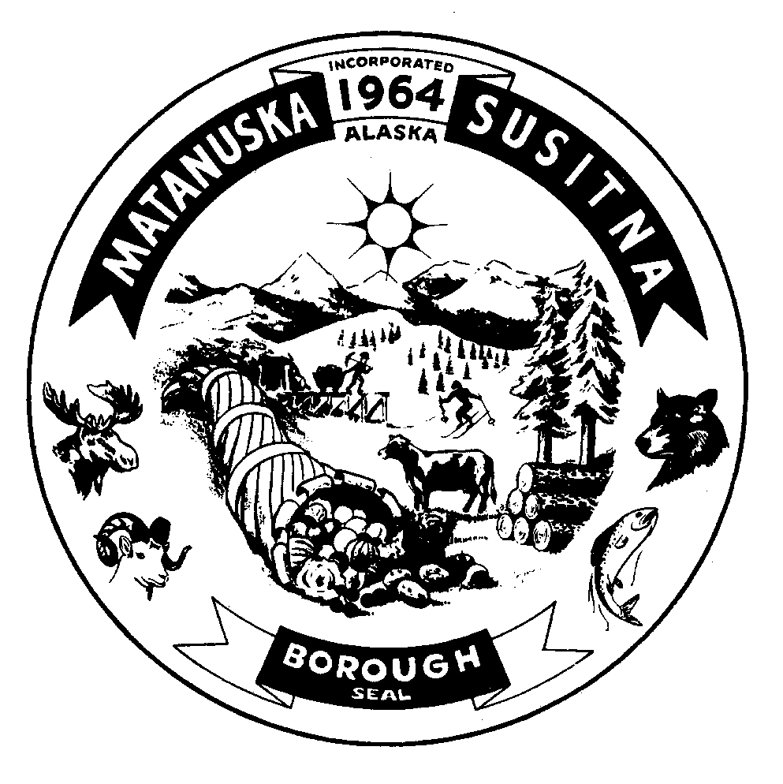

**Matanuska-Susitna Borough Libraries**

**Facility Use Permit**

**Big Lake – Sutton –**

**Talkeetna – Willow – Trapper Creek**

It is the policy of the Matanuska-Susitna Borough, Department of Community Development, Division of Recreation and Library Services, to make rental facilities available on a nondiscriminatory basis while maximizing revenue opportunities to offset expenses.

The primary use of the Matanuska-Susitna Borough Libraries facilities is that of a public library. When designated areas within any of the Borough Libraries are not in use for a library function these areas may be made available for rental on a first come, first serve basis. These are referred to herein as meeting areas.

The Matanuska-Susitna Borough subscribes to the American Library Association (ALA) policy regarding meeting rooms. The Matanuska-Susitna Borough Libraries meeting areas are made available, on an equitable basis, regardless of the beliefs or affiliations of individuals or groups requesting their use. Permission to use Matanuska-Susitna Borough Library facilities and/or grounds, whether rented or provided at no charge is not considered to be an endorsement or sponsorship of any group, individual, organization, or event.

Meeting areas covered by this permit include those designated by the librarians at each of the Borough Libraries. Please contact each of the libraries for a list of those designated areas.

Meeting Facility:

🞎 Big Lake 🞎 Sutton 🞎 Talkeetna

🞎 Willow 🞎 Trapper Creek

Organization Name Intended Use

Contact Person Address

City / State / Zip Contact phone number(s)

Fax and/or Email Address Estimated Attendance

____________________________________

Requested Date(s) of Event(s) Time(s) requested

Amount Due $ ________________

Amount Paid $ ________________

Cash _______ Check ____________

Is this a recurring event? (circle one) Yes No

**General Terms and Conditions of Use and Operations:**

1. **Confirmation:** A confirmed “Facility Use Permit” and payment of fees, if applicable, is required to reserve any meeting area. A signature is required to confirm the reservation. By signature, user agrees to comply with Matanuska-Susitna Borough Library Facility Use Permit.
2. **Time Increments:** A minimum reservation of one hour is required for any area. Set up and take down time must be included in a reservation. Additional times may be reserved in half-hour increments. Reservations are limited to those dates, times, rooms, and areas listed in the Facility Use Permit.

When meetings are scheduled outside regular library hours, the user will be responsible for:

* 1. Ensuring that the group remains in the meeting room area.
  2. Inform those not connected to the group that the library is closed.
  3. Remind those in attendance that smoking is not permitted in the library.
  4. Maintain orderly conduct among those in the building.
  5. Check the restrooms and meeting room at the conclusion of the meeting to ensure that everyone has left the building.
  6. Remain in the building until the last person has left.
  7. Ensure that all lights are turned off and the security system is turned on before leaving the building.
  8. Check the entry doors to ensure they are securely closed and locked.

1. **Reservation Priority:** Status order of a reservation is determined by date of receipt by the Facility Librarian of the signed Facility Use Permit and payment of any fees, if applicable, not the date of initial inquiry. Applications will be accepted for any use up to twelve months in advance of the date of event. Groups/Users who utilize Matanuska-Susitna Borough Library space on a regular basis are required to submit a new application each year.
2. **Fees:** There are no fees for Groups/Users who wish to use the community rooms during normal library hours. There is no limit as to the number of consecutive hours or days any group or individual may use the facility

For events held outside of normal library operating times, a fee of $40.00 per hour will apply. Should an event start during normal library operating hours and extend past the normal library operating hours, no fee will be charged. The Group/User will be responsible for locking up the facility.

1. **Conditional Use:** Meeting use is conditional upon user agreement to save, hold harmless, and indemnify the Matanuska-Susitna Borough from any claims, law suits, or judgments arising from loss, damage to property, or injury to persons from or during their activity or event.
2. **Insurance Requirements:** A certificate of insurance naming the Matanuska-Susitna Borough as an additional insured may be required. If Group/User cannot provide a certificate of insurance, insurance can be purchased through the borough at a nominal fee for each event scheduled.
3. **Cancellations:** Any cancellation or change to a confirmed reservation must be in writing, addressed to the Facility Librarian and specify the room(s), area(s), date(s) and time(s) to be canceled and/or changed and must be received twenty-four (24) hours in advance of the scheduled event to be eligible for a refund of fees. Failure to notify the Library of a cancellation, abuse of meeting room privileges; or noncompliance with the Facility Use Permit may result in immediate cancellation of use, denial of future use and forfeiture of fees. The Matanuska-Susitna Borough may cancel a reservation with twenty-four (24) hours notice because an area is needed for the purpose of conducting Library or other Borough business. A refund, if applicable, will be issued in this case.
4. **Additions/Alterations:** Additions to or alterations of Matanuska-Susitna Borough Library equipment, electrical or mechanical systems are prohibited. All decorations, scenery, etc. shall be erected without defacing the facility in any way, are subject to the approval of the Facility Librarian and shall be installed and removed from the facility within the time reserved. No items/materials may be affixed to walls, doors, flooring, furniture, etc. that will leave a residue, stain, scratch or otherwise mar these surfaces. No smoking, use of candles or open flame or decoration which may be flammable or combustible, or smoke or fog generating equipment or apparatus is allowed in any Matanuska-Susitna Borough Library facility.
5. **Termination:** The Library reserves the right to interrupt, terminate or cancel an event when, in the sole judgment of the Library, such act is necessary in the interests of public safety and/or user is in violation of this permit. User waives any claim for damages or compensation should the event be interrupted, terminated or canceled.
6. **Financial Liability:** Users are financially liable for any damage to the facility or library equipment caused by or as a result of their use, are required to report such damage as soon as possible after the incident and shall only take such action as is reasonably necessary to stop or contain damage. The Library will clean, repair or take such other reasonable action as is necessary to clean and/or repair such damage. Payment for any damage(s) is the responsibility of the user and shall be made to the Matanuska-Susitna Borough within thirty (30) days of receipt of any billing.
7. **Laws and Ordinances:** Use of any Library Facility shall be in accordance with all applicable Federal, State and local ordinances, statutes, rules and regulations that may apply. No individual or group shall be discriminated against because of race, religion, color, sex, national origin or disability.
8. **Posting of Meeting/Event:** No flyers, banners, or event information may be posted outside the building advertising events within the library or on the library grounds. Space will be provided within each facility to advertise or promote scheduled meetings or events. The notice must clearly state the sponsor of the event and a local contact telephone number. Promotional materials, press releases etc., must be worded so that it is clear to the general public the event is held at, but not sponsored by the Library. Non compliance with this policy may lead to immediate cancellation of the event and forfeiture of any rental fees paid.
9. **Room Capacities:** Users agree to observe posted room capacities and ensure that their use shall not adversely affect the needs of the Library and shall be conducted so as not to disturb others using the library.
10. **Supplies/Equipment:** Users are responsible for their own supplies, specialized equipment, set up and clean up. Tables, chairs and equipment must be returned to the original configuration, arrangement and/or storage location within the time reserved.
11. **Storage of Items:** No items may be stored for any user/group in any Matanuska-Susitna Borough Library. All supplies and equipment used in an event must be removed from the facility at the completion of each reservation period. Matanuska-Susitna Borough Libraries are not responsible for items left in, lost, or stolen from the Library or the Library grounds.
12. **Food and Drink:** Food and drink are only allowed in designated areas. Please check with the Librarian at each facility for those designated areas. The sale of food or drink in the facilities and/or on the grounds is prohibited. Serving of alcoholic beverages are prohibited in any of the facilities or on any of the grounds. Any violation of this policy is grounds for expulsion from the facility.
13. **Age Requirements:** Groups composed of persons under the age of 18 must be sponsored and supervised by an adult responsible for that group.
14. **Other Conditions:** The Library may impose such other reasonable conditions in addition to these specified herein as it is deemed necessary.
15. **User Responsibility:** Users are responsible to be familiar with and observe the Library Facility Use Permit in its entirety.
16. **Indemnification:** The Vendor shall indemnify, defend, and hold and save the borough, its elected and appointed officers, agents, and employees harmless from any and all claims, demands, suits or liability of any nature, kind, or character, including costs, expenses, and attorney’s fees. The Vendor shall be responsible under this clause for any and all legal actions or claims of any character resulting from injuries, death, economic loss, damages, violation of statutes, ordinances, constitutions, or other laws, rules or regulations, contractual claims, or any other kind of loss, tangible or intangible, sustained by any person, or property arising from Vendor’s or Vendor’s officers, agents, employees, partners, attorneys, suppliers, and subcontractors’ performance or failure to perform this agreement in any way whatsoever. This defense and indemnification responsibility includes claims alleging acts or omissions by the borough or its agents, which are said to have contributed to the losses, failure, violations, or damage. However, the Vendor shall not be responsible for any damages or claim arising from the sole negligence or willful misconduct of the borough, its agents, or employees.
17. **Waiver:** This permit and the policies within apply unless a waiver has been signed by the Matanuska-Susitna Borough Manager.

Signature Printed Name Date

Library Staff Signature Printed Name Date